VIVA GIRLS WEST POKOT AUGUST 2023
The Viva Girls Project was set to take place in 4 centers. Naramam, Chesra, Napakarin and Chepukat. Since the area has always been facing challenges like early pregnancies, school drop outs and early marriages.
CHESRA CENTER:
We had a total of 109 girls. The village and area is one of the most affected. The age bracket was from the age of 11-16years where the girls claimed most of their elder sisters and girls had been married off. They were taught on the dangers of early pregnancies where by at a young age they have not yet become strong to carry a baby, they were also at the verge of losing their lives during child conceiving. Early pregnancies would also stop them from going to school because they will be feeling afraid to get to class and even they will be obligated to take care of their children and by the time they finish up their class mates shall have moved miles ahead of them. School drop-out level also is very high at the place. The main reason is that these same girls are the ones who pay their examination fees and also buy for themselves school uniforms. They were encouraged that since it is the situation at hand, it was good for them to work as a team of girls through the struggle and uplift each other by encouraging each other through the journey. The girls in unison agreed that despite not receiving support from their parents, they would keep encouraging each other and work towards being great girls and change the stories of their community. On early marriages, the girls said at some point they were being forced so that their parents could get cattle, and they were being married off at very early ages where they cannot say NO. They were advised to always be courageous and share with their teachers in case they are being forced or talk to the Chief or assistant chief who would instead help them and protect them. And for the scenario where it was more of peer pressure, the girls were taught the importance of getting married at a ripe age where by they can stand up for themselves and will not need to be like slaves to their husbands where they can be beaten anyhow and even denied money to feed their children. The girls said they would wish to leave different lives as compared to that of their parents and ensure they would get to the universities.
. 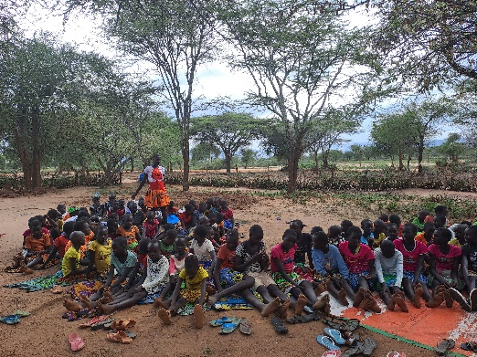
A picture of one of the girls who has managed to get to high school encouraging her young sisters.
CHALLENGES
- The greatest challenge was lack of support from their parents
- Inability to access necessities like sanitary towels.
- Lack of exposure on important social activities

RECOMMENDATIONS
- Requested for mentorship programs every holiday
- Asked for boys’ mentorship to be also included.
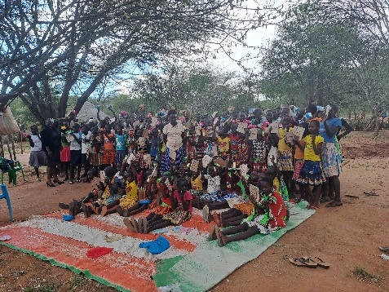
- Requested inner wears since most of them said they did not have.
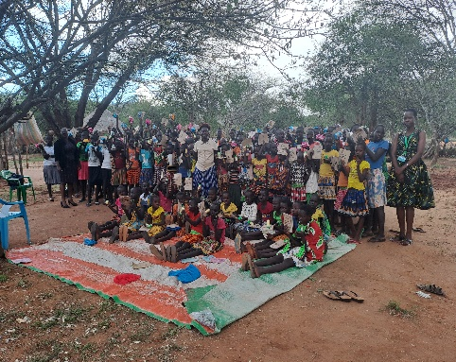
Pictures of Chesra girls after receiving their personal effects.

NARAMAM CENTER
There were a total of 118 girls within the age bracket of 12-24years. The topics of emphasis were on Importance of education, Early pregnancies, school drop outs and Relationship matters.
On the issues of education, they were taught on the importance of being educated as a girl and how the current world is moving and both boys and girls are given equal chances as long as they are educated. It was therefore very important for them to embrace education and be very serious with it since now it was the only way they could be able to compete with the male gender. Menstrual period was also another issue being discussed and the girls were taught on how it was very normal for every girl to undergo it and that they ought not to be afraid of anything but be proud of it and keep themselves clean during those days of the month. And if it was a first timer, they were advised to talk to their elder sisters and even their mothers to guide them on how to go about. A demonstration on how to use a sanitary towel was also done and how to dispose it after use. 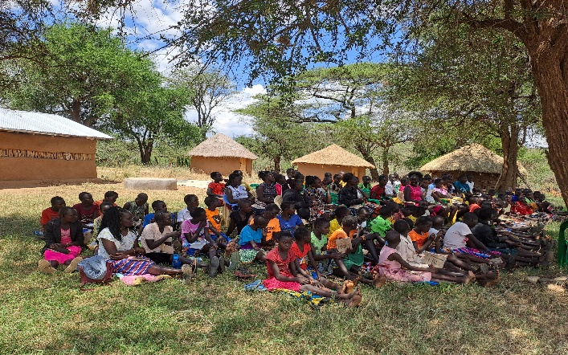
A picture of the girls keenly listening on the issues of menstrual periods.

Early pregnancies and school drop outs was still also being experienced in the area. This was mostly contributed to getting into relationships at early ages and not knowing how to go about it. They were therefore taught that the boy child had nothing major to lose because they would not carry the pregnancy or drop from school to look after the child but it would be the role of the girl and they would have lost a great deal. The boy would even not end up marrying them because they would want someone who is learned and the girls would end up being single mothers which is not a good this. The girls accepted to desist from these relationships and focus on being better girls in the community.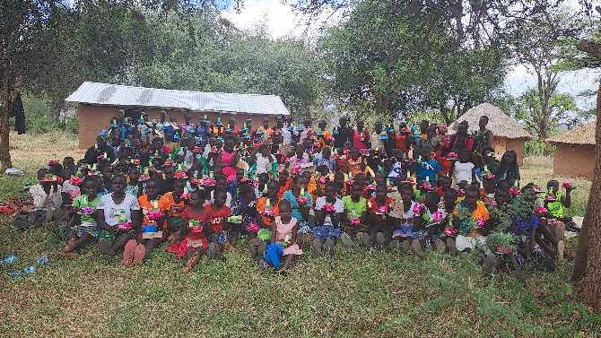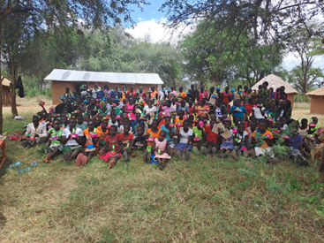

Pictures of the girls happy after eceiving personal effects like sanitary towels, soap, jelly, books and a pen.
CHALLENGES
- Lack of personal effects like sanitary towels and inner wears.
RECOMMENDATIONS
- Requested for boys training and mentorship.
- Requested for more trainings for girl child too
CHEPUKAT CENTER
There were a total of 89girls from the range of age 12 to 21. Female Genital Mutilation is still being practiced in the particular area and there was major emphasis because once they undergo the backward cultural activity they end up getting married off and even drop out of school because they end up feeling like they are women now and not girls. The girls were taught on the dangers of female genital mutilation. They were told their lives would be in danger in instances where they could bleed to death during this circumcision. They would also face dangers during times of birth and chances of surviving are very minimal. There was also the issue of a very popular dance “NASA”. The girls explained that it is the reason of the high rate of school dropout and early pregnancies. They were told that for the sake of their future and for them to be great and successful people in future, they had to desist from going to this dances and concentrate on more important things. Since most of their parents were not learned and the availability of local brews like changaa, the girls said they were facing difficult times because their parents and guardians were irresponsible and therefore said they do not pay their school fees and even do not provide food for their homesteads. They were advised that it was of great importance for them to accept that, that is the place they were born and could not change who bore them. It was therefore a duty for them as girls of that place to encourage each other and motivate themselves towards success. 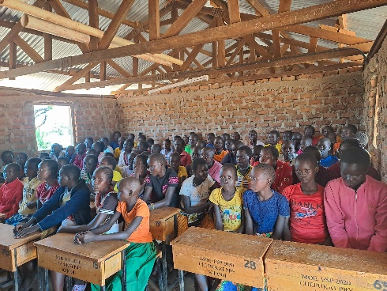
A picture of the girls keenly following on the teachings.
The girls also said that on early marriages, girls are always sent at an early age to stay at the boy’s parents house and grow up as if it’s their home and end up being married once they show signs of maturity. Girls were also being “harvested” as put by the girls. Whereby once drought hits the land, it was automatic that one girl would be married off by force and was more of a routine and they could not resist. They all agreed that they would report to the authorities like the chief and assistant chief because they wanted to study and further their educations.
Importance of education was also very much emphasized, they were told that education was the key to them becoming great and achieving what they want in life. And for girls in the area, there was none who had gotten to University and therefore in case of any opportunities it would definitely be offered and given to the boy child leaving them disadvantaged. Education was also stated to be of great importance because it would enable them to gain respect from the society and they would not be treated like any other uneducated woman where a man can just mistreat them anyhow and will not say anything. And since they had large tracts of land, the girls suggested and agreed that it would be better to report their parents to the chief in case they refuse to educate them yet they had the resources.
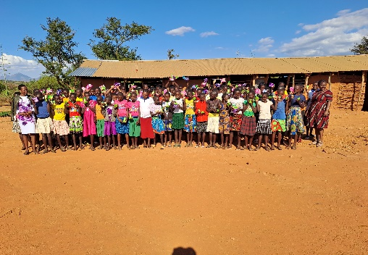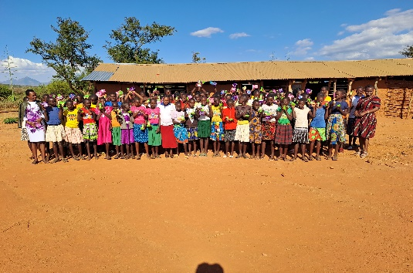
Pictures of the girls at Chepukat excited after receiving their personal effects.

CHALLENGES
- Lack of support from parents.
- They said they lacked role models in their area whom they would look up to.
- The famous dance “NASA” which was done at night and girls would be eloped.

RECOMMENDATIONS
- They requested for one meeting for their mothers since they wanted their mothers to be like those of Naramam.
- They requested for inner wears and trainings every holiday.
NAPAKARIN CENTER.
There were a total of 331 girls from the age of 9-25years. Since the number was too big, they were divided into two groups those below grade five and those in grade six and above.
The ones in grade five and below were being taught on the importance of being a good child at home, on the importance of education and not only going to school but doing well in class. Since they were still young they were told that menstrual flow existed and was normal and in case they experience it early they should not fear but share with their big sisters or Mothers.
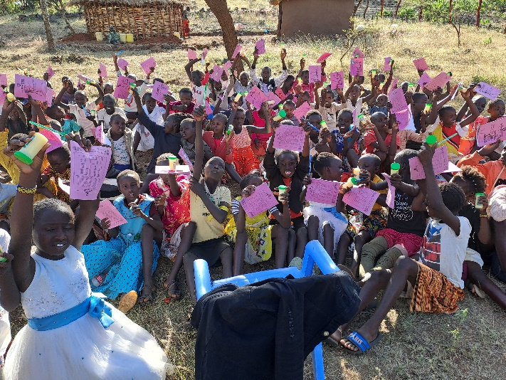
A picture of the small girls excited after the great lessons and receiving their personal effects.

For the seniors, they were taught on issues of Early marriages, early pregnancies and school drop outs.
Early pregnancies are the most evident thing where the girls said it was more of a normal thing. Most of the girls give birth at form one or two. The facilitator told them it was a very wrong thing because at that age they are still very young. It is also very difficult for them to concentrate with their studies while they have a child at home since they will be thinking more of them and not class work. Child bearing at an early age would also lead to school drop out because in most cases they shall be required to stay at home during the pregnancy period and look after their children until they are of age 2years, by the time they get to school their class mates will have finished school and they might end up losing morale and decide to just stay back at home
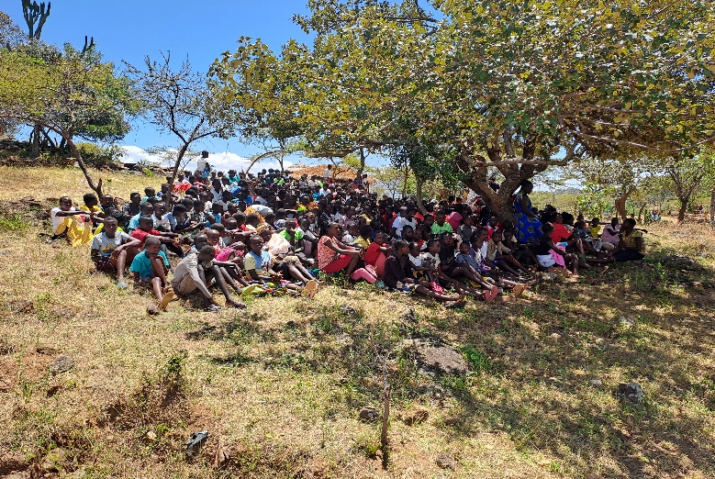
A picture of the girls keenly listening to the trainings on issues of early marriages.
The importance of girl child education was also emphasized and how the world is giving equal treatment and opportunities to learned boys and girls. It was also emphasized that through education they would gain respect from men and be viewed in a different way.
Peer pressure was also very evident from how the girls were expressing themselves on several issues more so on early pregnancies. They were advised that every person had different life to leave and decision to make. It is therefore very important as a girl to have a personal stand and unshakable self-esteem so that they shall not be easily carried away by what their peers are doing and end up messing up their lives.
Personal hygiene was also emphasized on how girls should maintain and keep themselves clean always more so during the time of Menstrual periods. They were told every girl ought to always look clean and smart both at home and at school. A demonstration on how to use sanitary towels was also done and also on how to dispose it well after use.
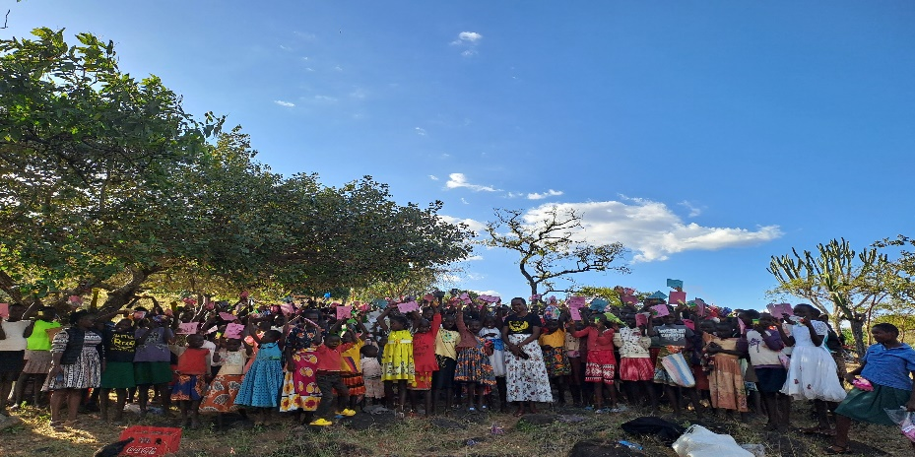
A picture of the girls very happy after being given some personal effects.
CHALLENGES
- Peer pressure was one of main challenge among the girls

RECOMMENDATIONS
- Requested for more trainings and also for the boys to be included
- Appreciated the training and asked for more trainings.

VIVA BOYS
The meeting was held at Naramam center with boys from Naramam, Chesra and Chepukat. We had a total of 268boys.
Since it was a first meeting ever for the boys, they were very happy and the issues discussed were on the importance of education, Drug and substance abuse, Personal development, Community engagements and Health and wellness.
On education, the boys were taught that education was very key and necessary for all of them since now they have to compete with other people and communities outside their own. It was also emphasized to be important because they shall be heads of their families and literacy is very important for them to lead their families well and also lead a decent life.
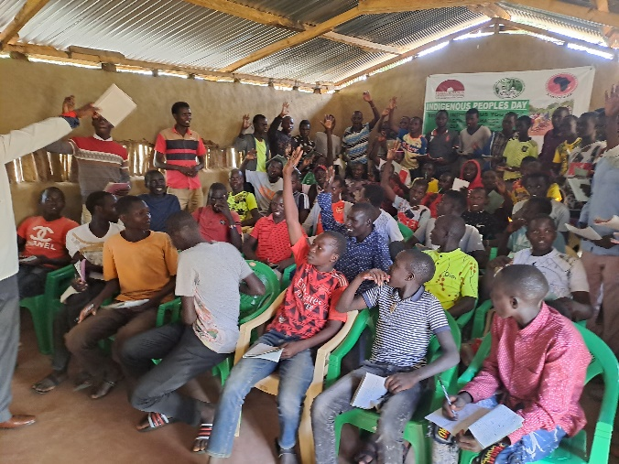
A picture of the boys actively contributing on the importance of education.
Health and wellness was also another point of discussion. They were told that boys always face a lot of challenges health wise and refuse/ fear to share because of masculinity and fearing that they will be ashamed and they will end up suffering in silence which is not a good thing. They were told to look for someone a big brother or a friend whom they can talk to and open up in case of such.
Personal development and Community engagements was also emphasized to the boys. They were taught that it is very important for them to engage in community development projects like reclaiming their land which would also be improving their personal relationships with the society at large. They were advised that they should take lead in the activities for the girls to follow up since they are the man power.
Drugs and Substance abuse is one of the things parents had complained to be affecting their boys so much, more so in the lower sides of Chesra. Boys were dropping out of school because of alcohol being sold in the surrounding area. They were taught the dangers of drug abuse which could adversely affect their health and would also lead to them not being able to give birth and will be an end to their generations and was not a good thing. They agreed that they would talk to the area authorities to stop the brewing of alcohol and that they would not take alcohol again and focus on being better men and greater persons.
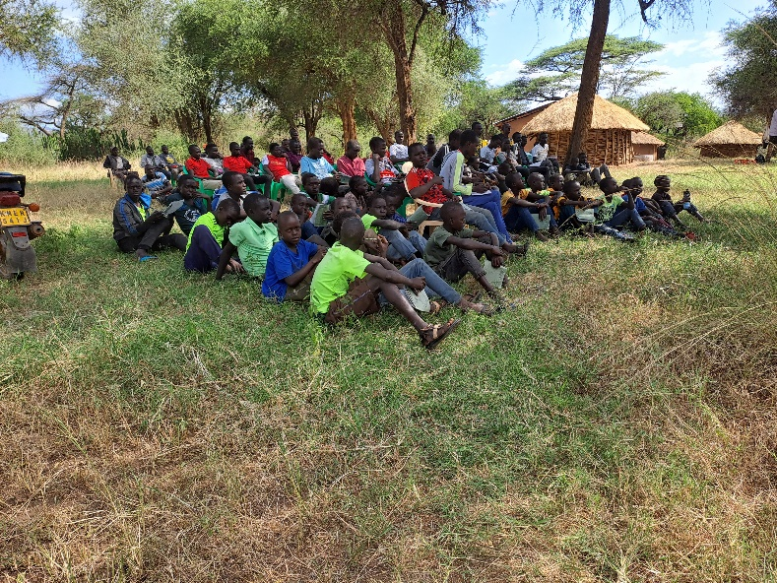
A picture of the small boys listening keenly on issues of health and substance abuse.
CHALLENGES
- Lack of funds to join universities and colleges
- Lack of direction and peer pressure
RECOMMENDATIONS
- Requested for two balls for the bigger boys and small boys and jerseys
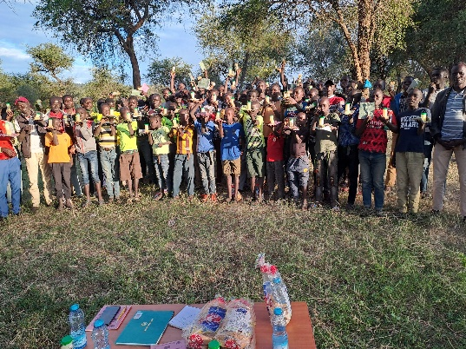
A picture of the boys happy after receiving some necessities.

