NARAMAM VIVA GIRLS DECEMBER 2022
The meeting which was held at Naramam center on 16th and had a total of 103 girls. The girls were to be taught on
- Importance of girl child education
- Healthy and unhealthy relationships.
- Dangers of female circumcision.
The meeting started with the girls singing some great and joyous songs ready for the teachings.
On the issues of girl child education, the facilitator started by asking them their class levels and we noticed that only one lady had gotten to the University. She therefore went ahead to teach them on the importance of education as girls whereby she told them that with the current and moving generation and world, it was very important for them to be educated since the world was becoming very competitive and it would also favor only the learned ones. She also told them that through education, one would be able to have financial stability which would save them from a lot of shame since they will not need to go around begging other people for foods or even basic needs. It would also raise their levels of living and they will also end up being respected in the society. They were also advised that they should act as motivating factors to their parents to keep paying their school fees and that they would do well by performing well in school and also by being respectful to their parents. The girls vowed and agreed to take their studies so serious so that they could be able to be like the girls from all the other places and even compete with them.
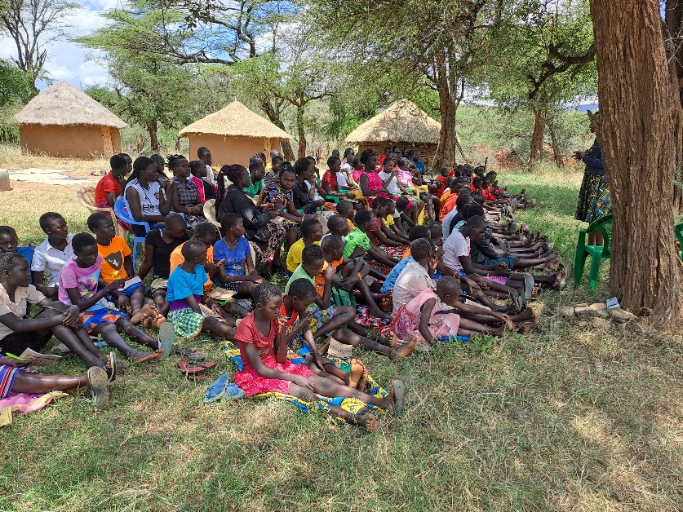
A picture of the girls listening keenly as they are being trained on the importance of education.
On issues of healthy and unhealthy relationships, they were advised that not everyone around them was worth being their friend and that every good person around them was worth being a friend. The girls were asked if they had boyfriends and if they knew the dangers of such relationships. On healthy relationships, they were told to be around friends who would impact their lives positively like engaging in group discussions or activities like helping their parents back at home. On unhealthy relationships, she emphasized on the issues of negative peer pressure. This is whereby most girls were seen engaging in several negative and bad activities like early relationships, early marriages and even being mothers at an early age. She told them that any friend that would alter them from focusing on their set goals and wanted them to do the opposite was a bad friend and it was good for them to cut off such people for they will make them fall into bad traps. The girls therefore unanimously agreed that they would not be friends with people who had different agendas other than the agenda of being better and succeeding.
On the issues of dangers of female circumcision, it was said that some few people were still practicing this backward form of culture. The girls were taught on its dangers which were several and very severe. They were even shown some videos and pictures of the same. One of the effects was that during circumcision, a girl might excessively bleed and end up dying. Secondly was that once they went this cultural practice, it would be very hard for them to keep up with their studies since they will feel like they are already all grown and same to their teachers and at the end decide to drop out of school and get married which was a very bad thing. Another very great effect was that if they undergo circumcision, when it comes to the time they would like to be married and have families, they shall have difficulties while giving birth and they shall need to undergo operations which will be risking their lives and they might end up loosing their lives or their children’s lives or even both of them but end up loosing their lives. They all agreed that they would not undergo the tradition and that they would also act as ambassadors against the same backward traditional act.
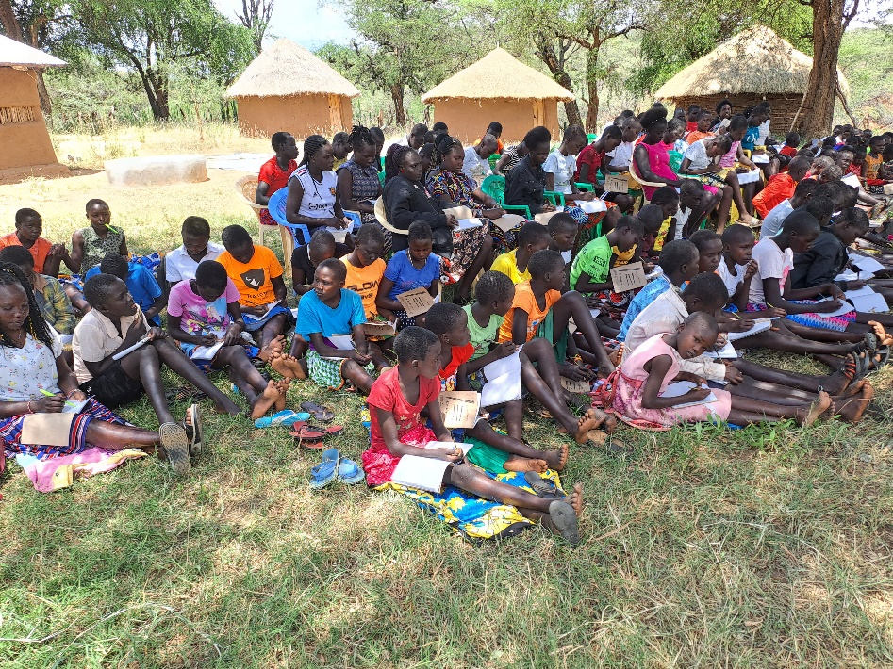
A picture of the girls keenly following on the teachings.
RECOMMENDATIONS
- The girls requested for more trainings each holiday.
- They also requested for some more necessities.

