NARAMAM VIVA GIRLS APRIL 2023
The meeting was held on 21st April at Naramam center and a total of 117girls attended.
The topics handled were:
- Girl child education and issues of early pregnancies
- Sexual and Reproductive health and rights
- Drugs and Substance abuse.
On girl child education and issues of early pregnancies, the area being remote, some of their parents did not really see the value of education and so some of the girls were not taking their studies seriously and some even already had children while at school. We taught them on the importance of girl child education by telling them that it is very important for a girl to be educated since it shall help them in several aspects. One of the points emphasized was the fact that the world is changing and both girls and boys are now being given equal opportunities in the job market. They were also taught that with education, one will be able to pursue her dreams and be what they have always aspired to be. It is also going to raise their social status and earn respect automatically in a patriarchal society because now they will end up in their dream careers and have financial stability which will lead to automatic respect. Early pregnancies were also one of the issues affecting the place, after teaching them on the importance of girl child education, we went ahead to tell them that it would be next to impossible for them to achieve their dreams if they engaged in early unhealthy relationships and get babies since now they will have to concentrate on their children and the school concentration will be drifted and they might even end up dropping out of school. Early pregnancies would also lead them to becoming single mothers since the boys might decide to keep up with their studies and end up marrying girls who also have their own professions. The girls in unison therefore agreed that they would not engage in unhealthy relationships so that they could achieve their set goals and dreams.
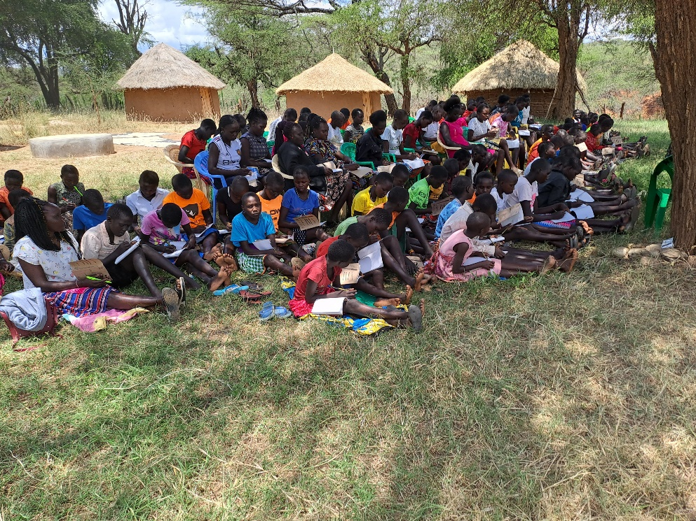
A picture of the girls listening on healthy and unhealthy relationships teachings.
On Sexual and reproductive health and rights, they were taught that sexual and reproductive health rights is related to multiple human rights including the right to life, the right to be free from torture, the right to health, the right to privacy, the right to education and the prohibition of discrimination. The importance of this rights were stated to be, leads to decrease of early child marriages, decrease teenage pregnancies and prevent transmission of sexually transmitted infections. They went ahead to be taught on the menstrual cycle and were told that it was normal for every girl to under go that. And that those who had not yet experienced should not be afraid but always look for someone they could talk to more so their elder sisters or mothers. They were also urged that it was very important for them to keep very high hygiene during the period, they should at least bathe twice in a day and change their sanitary towels like thrice.
On drugs and substance abuse, the girls said that since the previous meetings, it has gradually reduced and that few people were engaging in it. They were therefore taught on the dangers of engaging in drugs and substances abuse hereby they were told it would bring about both physical and mental damages and this will definitely alter their ways of existence. Through engagements in drugs and substance abuse, they would have their judgement impaired and end up making very wrong decisions. They might even get raped and acquire diseases or even get unwanted pregnancies which will lead to them being depressed and even traumatized. The girls therefore agreed that they shall be ambassadors of drugs and substances abuse and that they shall educate their peers and even parents on the same.
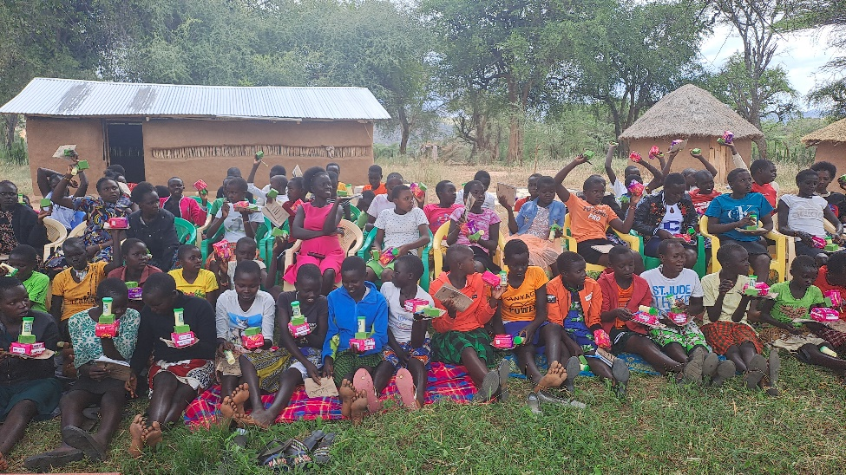
A picture of the girls happy after receiving some necessities.
RECOMMENDATIONS.
- The girls requested for more meetings every holiday
- The girls requested for inner wears in the next meetings.

